CSA1017 - SOFTWARE ENGINEERING

NAME: V.VENKATA KUMAR REDDY

REGNO: 192311350

SLOT: C

Raptor

Exp4:

The string is a sequence of characters placed in double quotes (” “). Performing different operations on string data is called String Handling. Strings are immutable. Whenever a change to a String is made, an entirely new String is created. If we want to store a group of characters we can use a char array. String provides various methods to perform different operations on strings. Using Raptor draw a flowchart to display the total number of characters in the string and returns it.

AIM:

The aim of this program is to create a raptor flowchart that accepts a string as input, calculates the total number of characters present in the string using the string length function, and displays the character count as the output. This helps in understanding basic string handling operations in raptor.

screen shot:

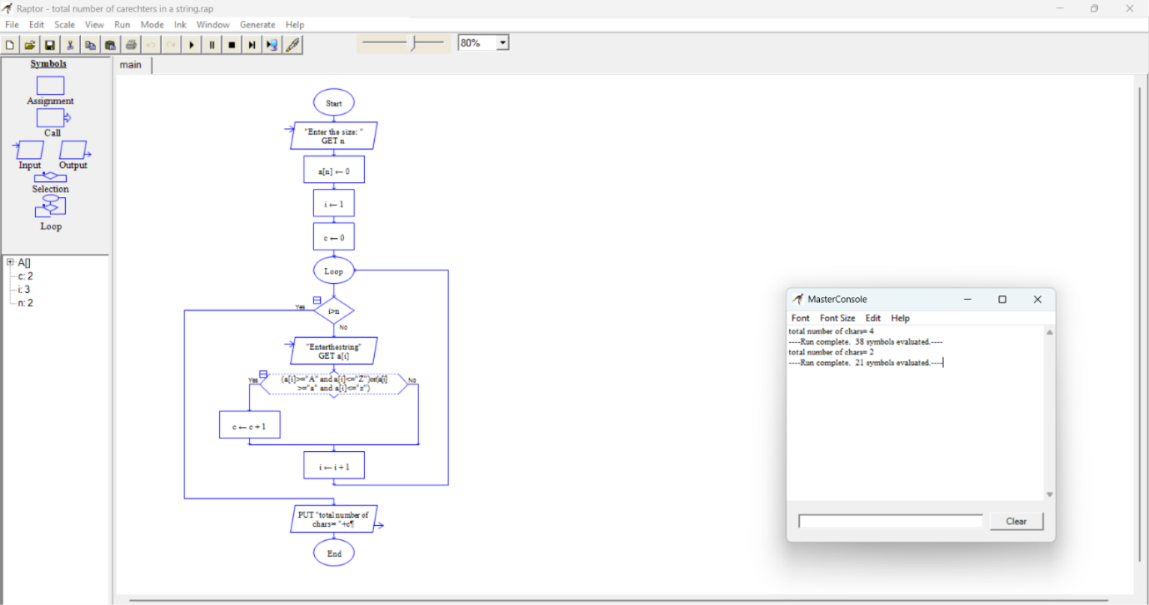

Exp5:

Using Raptor – Draw and validate a flowchart for a given string of lower case English alphabets. One can choose any two characters in the string and replace all the occurrences of the first character with the second character and replace all the occurrences of the second character with the first character. Using Raptor draw and validate the flowchart lexicographically smallest string that can be obtained by doing this operation at most once.

AIM:

The aim of this program is to create and validate a RAPTOR flowchart that accepts a string of lowercase English alphabets and performs at most one character swap operation. The flowchart replaces all occurrences of one selected character with another and vice versa to generate and display the lexicographically smallest possible string.

Screen shot:

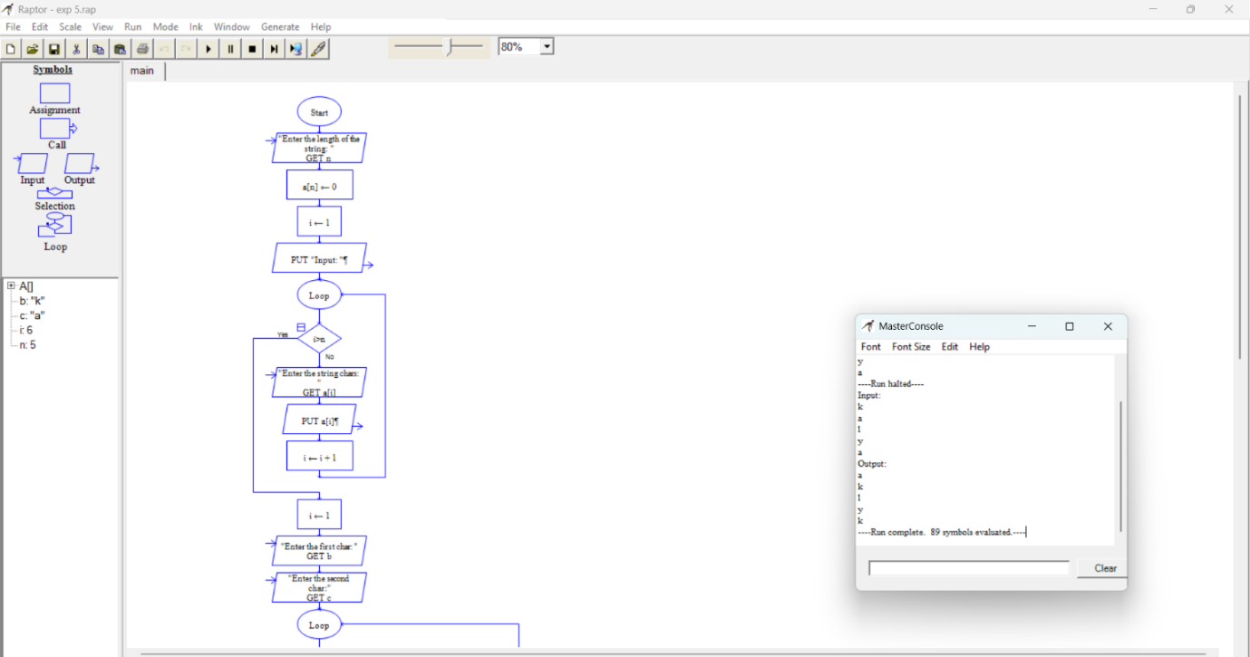

Exp8:

Cyclomatic Complexity in Software Testing is a testing metric used for measuring the complexity of a software program. It is a quantitative measure of independent paths in the source code of a software program. Cyclomatic complexity can be calculated by using control flow graphs or with respect to functions, modules, methods or classes within a software program. Cyclomatic complexity for a flow graph G is V(G)=E-N+2. Cyclomatic complexity is a software metric (measurement), used to indicate the complexity of a program, Cyclomatic complexity = E - N + P where, E = number of edges in the flow graph, N = number of nodes in the flow graph, P = number of nodes that have exit points. Find Cyclomatic Complexity for a graph having number of edges as 17, number of nodes as 13 and number of predicate nodes in the flow graph as 5.

AIM:
The aim of this program is to calculate the Cyclomatic Complexity of a software program using the given flow graph values. It determines the complexity by applying the Cyclomatic Complexity formula based on the number of edges, nodes, and predicate nodes in the flow graph.

Screen shot:
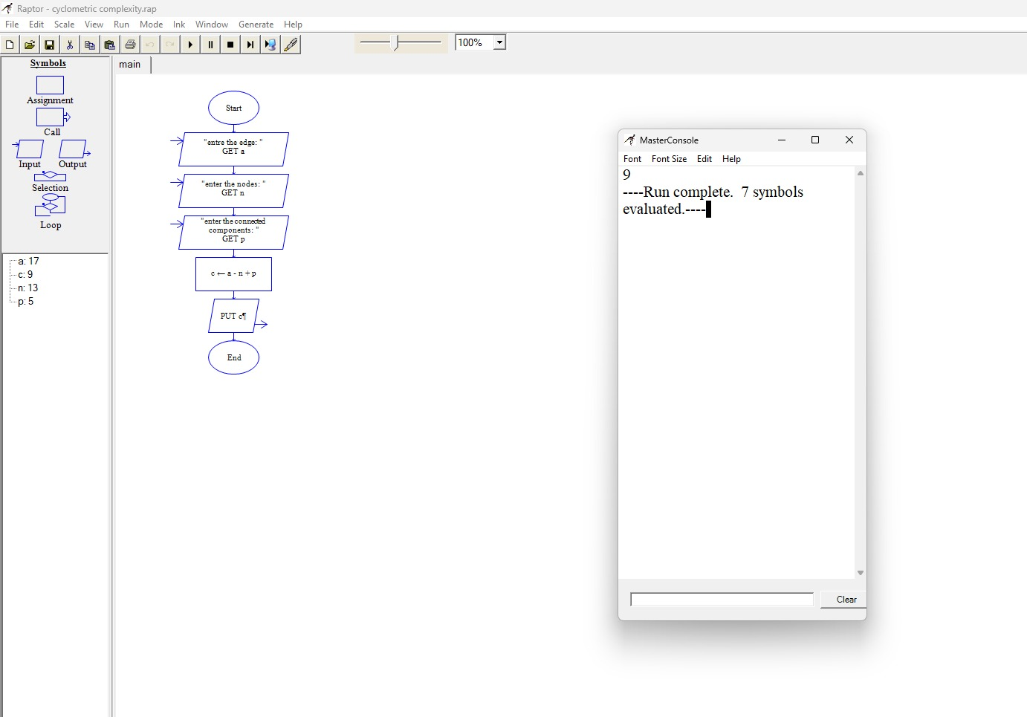

Exp:
Using RAPTOR, draw and validate a flowchart to check whether a given number is an Armstrong number. The flowchart should accept a number as input, calculate the sum of each digit raised to the power of the total number of digits, and determine whether the given number is an Armstrong number or not.

AIM:

The aim of this program is to create and validate a RAPTOR flowchart that accepts a number as input and checks whether it is an Armstrong number. The flowchart calculates the sum of each digit raised to the power of the total number of digits and compares the result with the original number to display the appropriate output.

Screen shot:

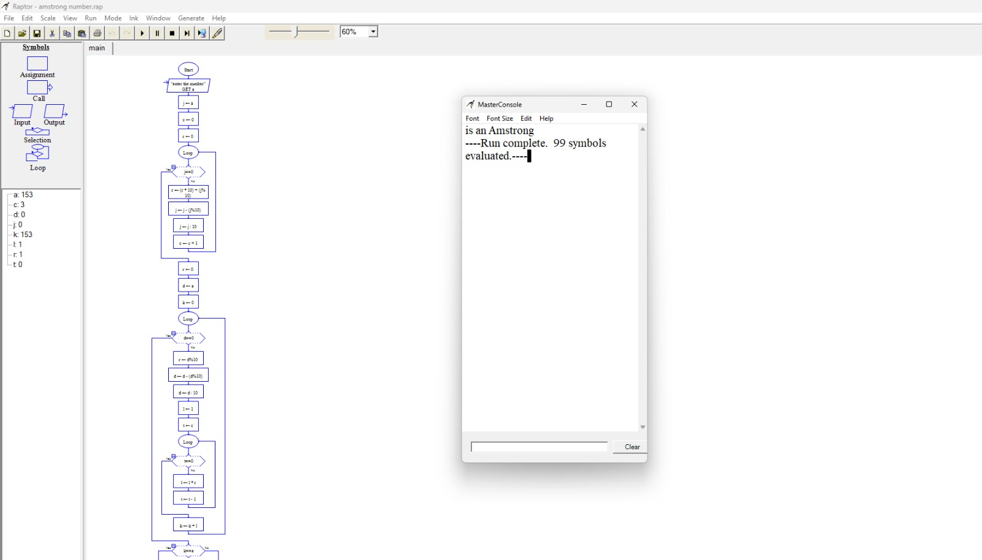

Exp:
Using RAPTOR, draw and validate a flowchart to calculate the factorial of a given number. The flowchart should accept a positive integer as input, compute its factorial using a loop, and display the result.

Aim:
The aim of this program is to create and validate a RAPTOR flowchart that accepts a positive integer as input and calculates its factorial using an iterative loop. The flowchart then displays the factorial of the given number as the output.

Screen shot:

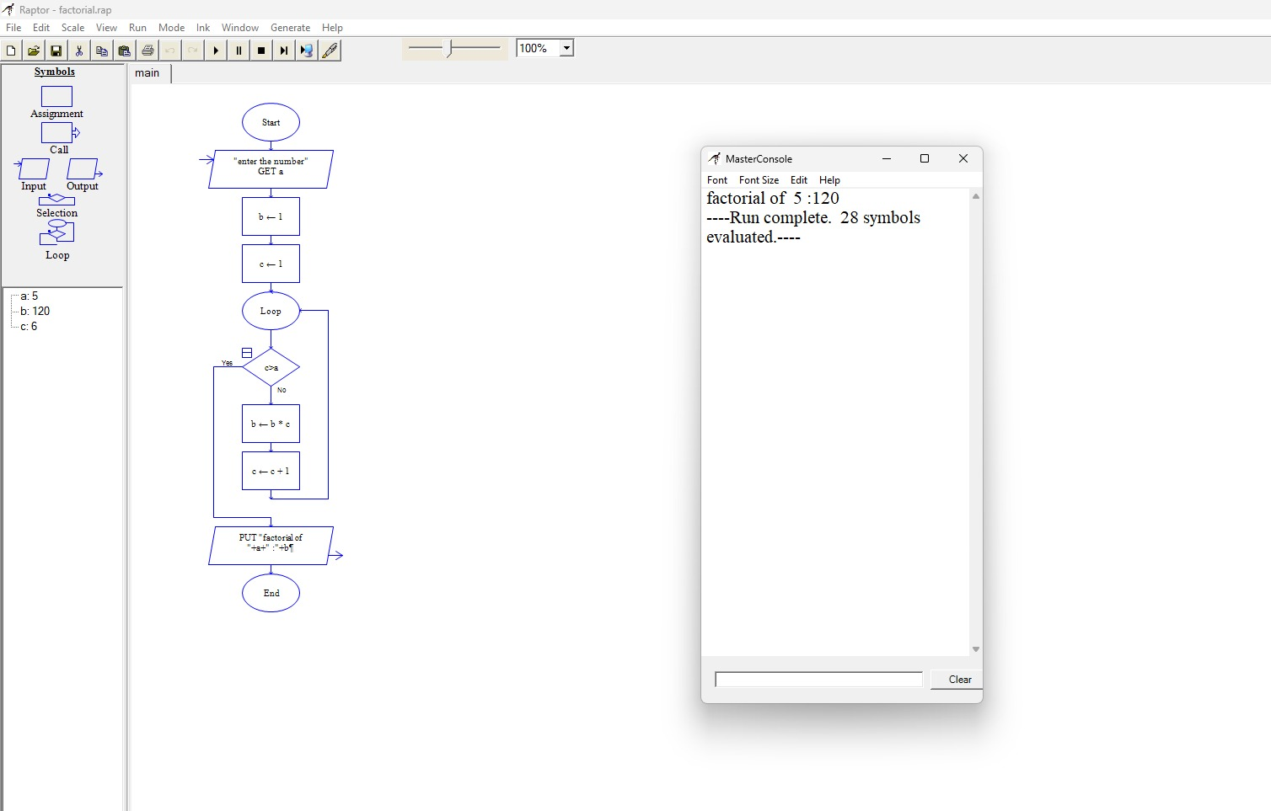

Exp:

Using RAPTOR, draw and validate a flowchart to calculate the area of a circle. The flowchart should accept the radius of the circle as input, compute the area using the formula $πr^{2}$, and display the calculated area.

Aim:
The aim of this program is to create and validate a RAPTOR flowchart that accepts the radius of a circle as input and calculates its area using the formula Area = π × r². The flowchart then displays the calculated area of the circle as the output.

Screen shot:
